Exercise 2
IAD2133 | OBJECT ORIENTED PROGRAMMING
Chapter 2 - Elementary Programming

NAME : balqis binti awaluddin PHONE :0147992127

MATRIC : 3252002501 EMAIL : 3252002501@student.unisel.edu.my
NO.

Scanner Class
Which method in the Scanner class is used specifically to read a value of type double from the console?
- nextDouble()
- getDouble()
- inputDouble()
- readDouble()

Java Identifiers (True/False)
A Java identifier can legally begin with a digit, provided the rest of the characters are letters or underscores. A. True
B. False

Valid Identifier
Which of the following is a valid Java identifier?
- 123geeks
- sum_&_difference
- My Variable
- $myvariable

Modulus Operation
If you calculate (6 + 10) % 7, what is the result?
- 1
- 3
- 2
- 0

Floating-Point Literal
By default, a floating-point literal such as 5.0 is treated as which data type in Java?
- float
- long
- double
- int

Integer Division
What is the result of 5 / 2 in Java?
- 2.5
- 3
- 2
- 0

System Time
The method System.currentTimeMillis() returns the number of milliseconds elapsed
since:
- The time the program started
- Midnight today
- January 1, 1900 GMT
- January 1, 1970 GMT

Type Casting
When casting a double to an int, such as (int) 3.9, what happens?
- Fractional part is truncated
- Stored elsewhere
- Runtime error
- Rounded

Software Development Phase
Which phase focuses on understanding the problem and documenting system requirements?
- System Analysis
- Requirements Specification
- Implementation
- System Design

Type Conversion
If one operand is double and the other is int, what is the result type? A.
float
- long
- int
- double

System Analysis (True/False)
System Analysis involves identifying classes, interfaces, and relationships. A.
True
B. False

Augmented Assignment
Which is an example of an augmented assignment operator?
- +=
- &&
- ++
- ==

Acronym in System Design
What does IPO stand for?
- Input, Process, Output
- Application Programming Interface
- Graphical User Interface
- Integrated Development Environment

Expression Equivalence (True/False)
If sum is an integer, then sum += 4.5 is equivalent to sum = (int)(sum + 4.5).
- True
- False

Data Type Error
What error occurs when a value exceeds a data type’s range?
- Undeclared Variable
- Integer Overflow
- Round-off Error
- Redundant Input

Maintenance Phase
Which phase focuses on improving the system and fixing bugs over time?
- Implementation
- Maintenance
- Deployment
- Testing

Expression Evaluation
What is the value of:
3 + 4 * 4 + 5 * (4 + 3) - 1
- 83
- 53
- 112
- 48

Identifier Length (True/False)
Identifiers in Java can be of any length.
- True
- False

Character Data Type
Which data type stores a single character in Java?
- char
- boolean
- byte
- String

Return Type (True/False)
currentTimeMillis() returns a value of type int.
- True
- False

Exercise code 1: Area of a Circle
Concept: Variables, Constants, and Basic Input.
Problem: Write a program that reads the radius of a circle from the user and computes the area. Use the constant Math.PI for the calculation.
● Formula: $Area = radius \times radius \times \pi$ Java
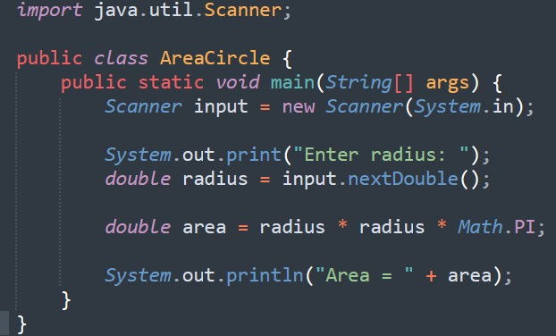
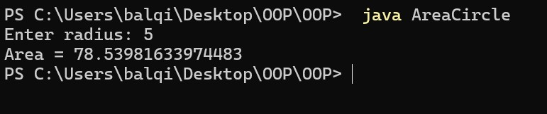

Exercise code 2: Temperature Converter
Concept: Arithmetic Expressions and Floating-Point Math.
Problem: Write a program that reads a Celsius degree in a double value from the console, then converts it to Fahrenheit and displays the result.
● Formula: $Fahrenheit = (9 / 5) \times Celsius + 32$ ● Hint:
Be careful with integer division when calculating 9/5! Java
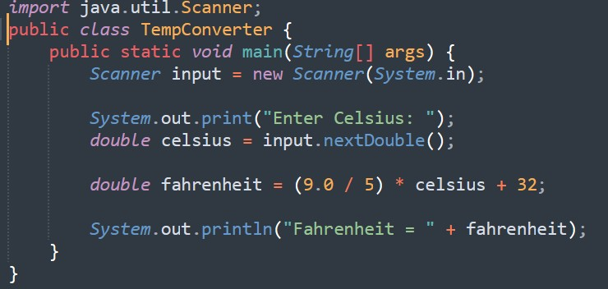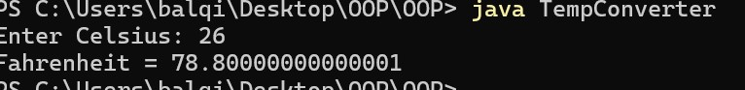

Exercise code 3: Time Decomposition
Concept: Integer Division (/) and Remainder Operator (%).
Problem: Write a program that prompts the user for a total number of seconds (e.g., 500) and converts it into minutes and remaining seconds (e.g., 8 minutes and 20 seconds). Java
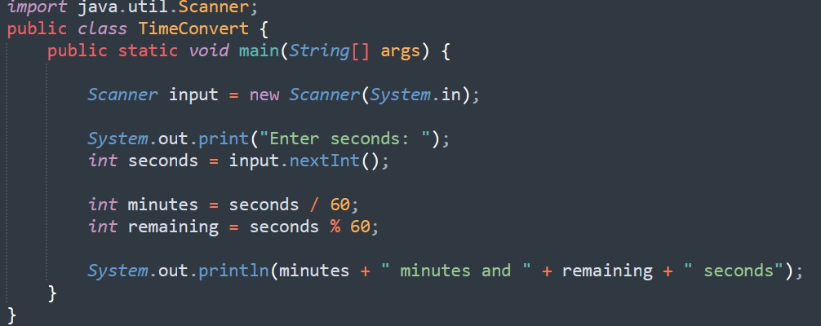
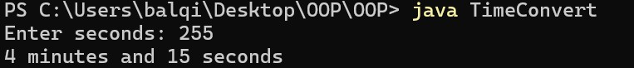

Exercise code 4: Digit Summation
Concept: Modulo and Division for digit extraction.
Problem: Write a program that reads an integer between 0 and 1000 and adds all the digits in
the integer. For example, if an integer is 932, the sum of all its digits is $9 + 3 + 2 = 14$. Java
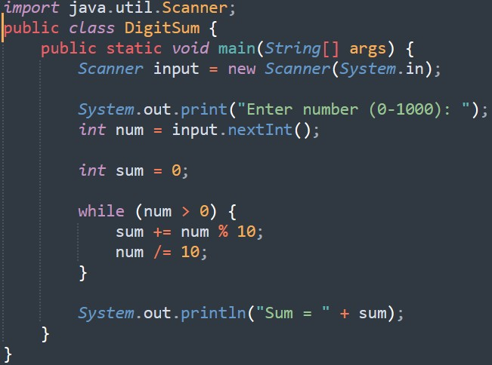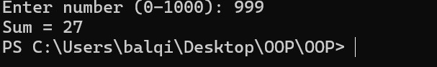

Exercise code 5: Gratuity Calculator
Concept: Combining multiple inputs and percentages.
Problem: Write a program that reads the subtotal and the gratuity rate (percentage), then computes the gratuity and the total. For example, if the user enters 10 for subtotal and 15% for gratuity rate, the program displays $1.5 as gratuity and $11.5 as total. Java
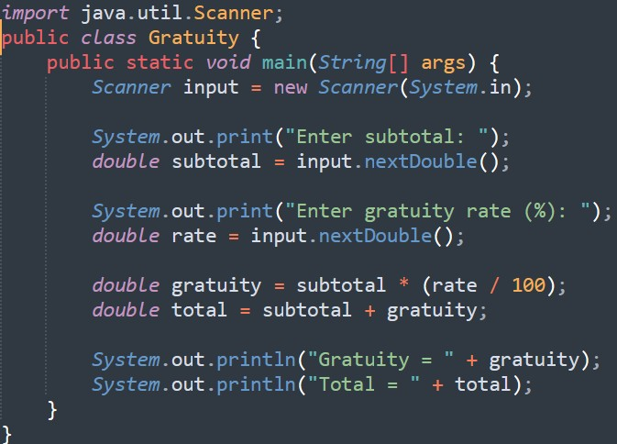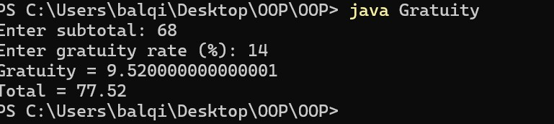

Exercise code 6: Exponentiation and Math Functions Concept: Using the Math.pow(a, b) method.
Problem: Write a program that displays a table of powers. For each number $n$ from 1 to 5, calculate $n^{n+1}$.
● Expected output row 1: 1 2 1 (where 1 is $n$, 2 is $n+1$, and 1 is $1^2$) Java
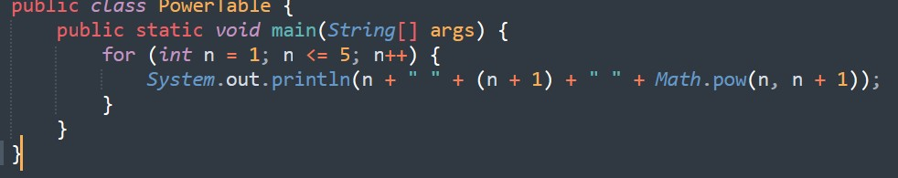
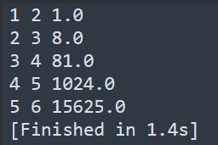

Exercise code 7: Numeric Type Casting
Concept: Implicit vs. Explicit Casting.
Problem: Create a program that prompts the user for three integers, calculates their average, and displays it as a double. Note: Ensure the result has decimal precision (e.g., the average of 1, 2, and 4 should be 2.333, not 2.0).
Java
